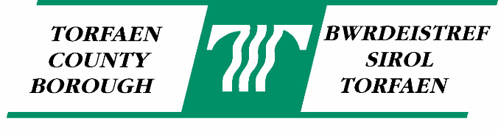
PREVENTING THE SPREAD OF INFECTIOUS DISEASE : SOME USEFUL TIPS

If you or a member of your family think or know they have an infectious disease, it is important to prevent it from spreading to other people. The same tips should also be followed for viruses.

These illnesses can quickly be spread from person to person by poor personal hygiene and can cause severe illness, particularly in elderly persons or young children.

Here are some simple tips on hygiene at home which will help prevent your family from becoming ill:-

- Regular and thorough hand washing using soap and warm running water is the best way to stop other people from becoming ill, particularly after using the toilet and before preparing food. Thorough hand drying is also important! Liquid soap, disposable hand towels and alcohol hand gel are strongly recommended.

- Make sure that hands are washed thoroughly after caring for sick people as you can become infected by handling soiled clothes, bedding etc.

- Soiled clothing and bed linen should be washed separately from other clothes in a domestic washing machine at the highest temperature that they will tolerate (e.g. 60°C plus for linen). If the items cannot be placed straight into the washing machine, scrape any soiling into the toilet bowl before it goes into the washing machine. A pre-wash cycle of the washing machine may then be used.

- Make sure that the outside of the washing machine is wiped down with hot water and detergent after using it for soiled clothing, bedding etc.

- Any spillages or contamination should be cleaned up immediately with absorbent materials, e.g kitchen roll or paper towels. Clean the area with hot water and detergent afterwards – this should kill any bacteria present.

- Thoroughly clean and disinfect toilet seats, flush handles, taps, door handles etc. regularly throughout the day. Hot water, detergent and/or disinfectant should be used. Using solutions such as Milton, Domestos, Dettol or alcohol wipes etc should do the trick. Pour neat disinfectant around the toilet bowl at night and flush next morning.

- Cleaning of soiled items should not take place in food preparation areas (e.g. in sinks in domestic kitchens).

- Supervise young children using the toilet and whilst hand washing.

- Do not share towels or flannels.

- Persons suffering from diarrhoea should avoid using toilets in other households or places if they can – particularly if cleaning the toilets afterwards may be an issue.

- Avoid preparing food for other people if suffering from diarrhoea or other food poisoning symptoms.

If you or a member of family are unwell and your work involves handling food or drink, or you nurse or work with the young, sick or elderly you must tell your employer.

It is strongly recommended that any ill person/s, especially young children, avoid returning to playgroups, school or work for at least 48 hours after their symptoms have gone.

For further advice on infectious disease, please contact your local G.P and/or local Environmental Health Department at Torfaen County Borough Council on 01633 762200. Alternatively visit our website – www.torfaen.gov.uk

